THE QUEEN’S PLATINUM JUBILEE

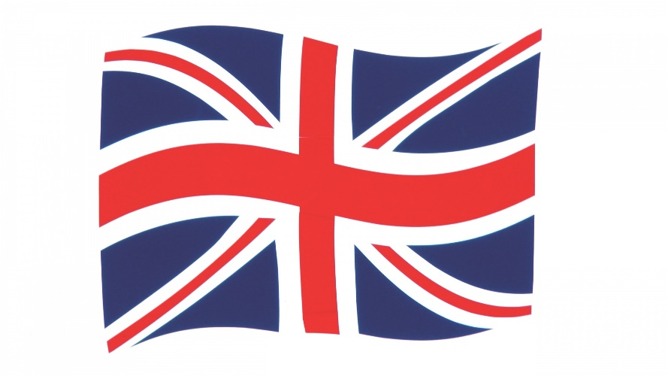

MANY THANKS TO ALL WHO CAME
TO MILSON’S JUBILEE CELEBRATION

THANK YOU FOR ALL YOUR
GENEROUS CONTRIBUTIONS

AND FOR SUCH AN
ENJOYABLE AFTERNOON

